WEBTECH CT1
CGI
CGI is what happens between client sending a request to the server and server responding to the request.
CGI is a standard interface by which the web server passes the client's request to a program and receives the response from that program
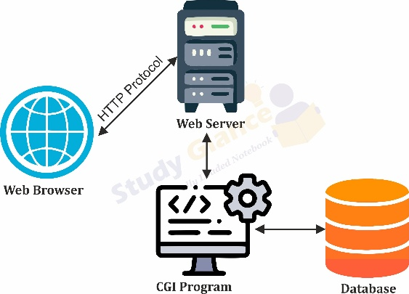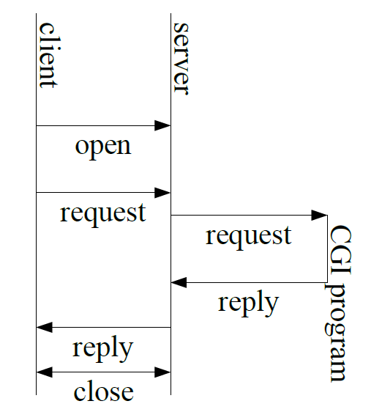
- Client open connection to server
- 👤 User sends request (via browser)
- 🌐 Web server receives it
- 🔁 Server passes request to a separate program (CGI program)
- ⚙️ Program processes it
- 📤 Sends response back to server
- 🌐 Server sends response to user
- Client and server close connection
Sending the Request to the Program
- * The web server sends information to the program using environment variables
  - * This information includes
                - HTTP headers
                - Server information
                - Client information
                - Information about the request
                - Receiving Form Data
  - A CGI program can receive form data using GET or POST methods. In GET, the data is appended to the URL and stored in the QUERY_STRING environment variable. In POST, the data is sent through standard input (stdin), and the CONTENT_LENGTH variable specifies how much data should be read, since no EOF signal is provided.
Sending The Reply
In CGI, the program sends its response by writing to standard output (stdout). The output must consist of a header (at least the Content-type), followed by a blank line, and then the actual content such as HTML or text. Commonly, the header used is Content-type: text/html.
Security Concerns
The client is sending a request that causes the server to execute a program. The program uses data provided by the client. Client data can not be trusted!
Security Tips in CGI
Security is an important concern in CGI because client requests can trigger the execution of server-side programs using user-provided data. The following precautions must be taken:
- Do not trust client-side validation
Client-side restrictions such as maxlength in form fields can be bypassed. Therefore, all input must be validated on the server side.
- Avoid executing user-provided data
Functions like eval or improper handling of input can allow attackers to execute malicious code. User input should never be directly executed.
- Validate and sanitize input
All user inputs must be checked for correctness and cleaned to remove harmful characters to prevent attacks like SQL injection.
- Handle file names and paths carefully
User-provided file names can be manipulated (e.g., "../../../etc/passwd") to access restricted files. Proper validation and directory restrictions should be applied.
- Follow secure coding practices
Use safe methods (e.g., prepared statements) and avoid constructing commands or queries directly using user input.
- Don’t store data where it can be accessed by http client
- Always escape user-supplied data before outputting it as HTML

Some Technical Issues
- * CGI programs can be written in any programming language (C, C++, Java, Perl, bash,...)
  - * The web server is configured to treat executable files in certain special directories as CGI programs For us, this is ~username/cgi-bin/
  - * The user ID that the CGI program is run under depends on the server configuration For us, it is the UID of username
  - * The CGI program is restricted to performing operations permitted to that user

JAVA Servlets -
Java Servlets are programs that run on a Web server and act as a middle layer between a requests coming from a Web browser or other HTTP client and databases on the HTTP server.
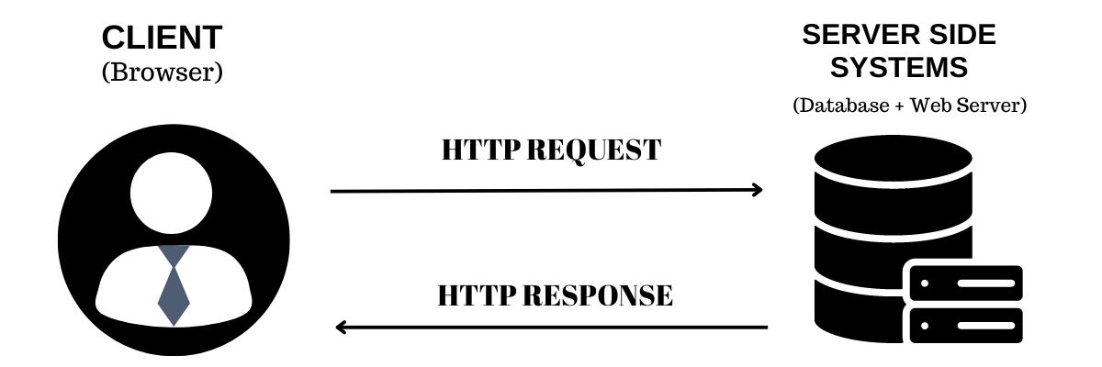
- Using Servlets, you can collect input from users through web page forms, present records from a database or another source, and create web pages dynamically.
- Performance is significantly better.
- The web server has its own memory
- Servlets run inside that same memory
No extra memory allocation
No separate program launch
- Servlets are platform-independent because they are written in Java.
- The Java Security Manager restricts what servlets can do on the server, ensuring they run safely within controlled limits—hence they are considered “trusted.”
- The full functionality of the Java class libraries is available to a servlet. It can communicate with applets, databases, or other software via the sockets and RMI mechanisms that you have seen already.
Servlets Tasks
Servlets perform the following major tasks –
- Read the explicit data sent by the clients (browsers). This includes an HTML form on a Web page or it could also come from an applet or a custom HTTP client program.
- Read the implicit HTTP request data sent by the clients (browsers). This includes cookies, media types and compression schemes the browser understands, and so forth.
- Process the data and generate the results. This process may require talking to a database, executing an RMI or CORBA call, invoking a Web service, or computing the response directly.
- Send the explicit data (i.e., the document) to the clients (browsers). This document can be sent in a variety of formats, including text (HTML or XML), binary (GIF images), Excel, etc.
- Send the implicit HTTP response to the clients (browsers). This includes telling the browsers or other clients what type of document is being returned (e.g., HTML), setting cookies and caching parameters, and other such tasks.
SERVLET LIFE CYCLE
A servlet life cycle can be defined as the entire process from its creation till the destruction. The following are the paths followed by a servlet.
- The servlet is initialized by calling the init() method.
- The servlet calls service() method to process a client's request.
- The servlet is terminated by calling the destroy() method.
- Finally, servlet is garbage collected by the garbage collector of the JVM.

The init() Method
  - The init method is called only once. It is called only when the servlet is created, and not called for any user requests afterwards. So, it is used for one-time initializations, just as with the init method of applets.
  - The servlet is normally created when a user first invokes a URL corresponding to the servlet, but you can also specify that the servlet be loaded when the server is first started.
  - When a user invokes a servlet, a single instance of servlet gets created, with each user request resulting in a new thread that is handed off to doGet or doPost as appropriate.
  - The init() method simply creates or loads some data that will be used throughout the life of the servlet.
  - The init method definition looks like this –
  - Public void init() throws ServletException {
  - // Initialization code
}
The service() Method
- The service() method is the main method to perform the actual task. The servlet container (i.e. web server) calls the service() method to handle requests coming from the client( browsers) and to write the formatted response back to the client.
- Each time the server receives a request for a servlet, the server spawns a new thread and calls service.
- The service() method checks the HTTP request type (GET, POST, PUT, DELETE, etc.) and calls doGet, doPost, doPut, doDelete, etc. methods as appropriate.
- Here is the signature of this method −
- The service () method is called by the container and service method invokes doGet, doPost, doPut, doDelete, etc. methods as appropriate. So you have nothing to do with service() method but you override either doGet() or doPost() depending on what type of request you receive from the client.
- The doGet() and doPost() are most frequently used methods with in each service request. Here is the signature of these two methods.
- public void service(ServletRequest request, ServletResponse response) throws ServletException, IOException {
}

The doGet() method
The doGet() method is used to handle HTTP GET requests sent by the client (usually a browser).
Feature | Description
Data location | URL
Security | ❌ Less secure
Length limit | ✔ Limited
Bookmarkable | ✔ Yes
Used for | Fetching data
The doGet() method is used to handle HTTP GET requests. It is invoked by the service() method of the servlet when a client sends a GET request. Data is sent through the URL as a query string and can be accessed using request.getParameter(). It is commonly used for retrieving data from the server.
The doPost() method
doPost() is used when the client sends data to the server using the POST method (usually from a form)
User fills form
↓
Clicks submit
↓
POST request sent
↓
service()
↓
doPost()
↓
Response sent back

Difference
Feature | doGet() | doPost()
Data location | URL | Request body
Security | ❌ Less secure | ✔ More secure
Data size | Limited | Large
Bookmark | ✔ Yes | ❌ No
Use case | Fetch data | Send/submit data
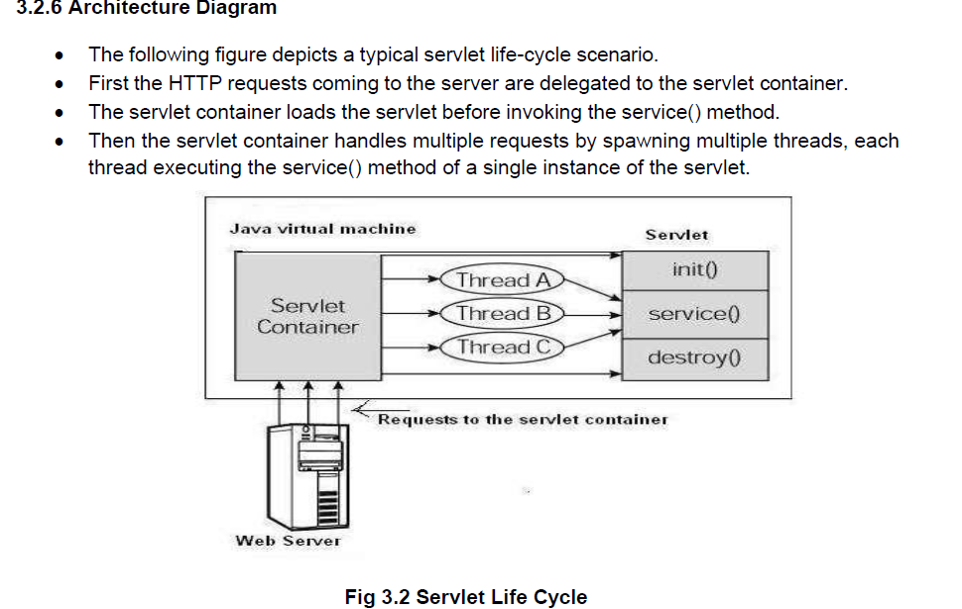

The destroy() Method
The destroy() method is called only once at the end of the life cycle of a servlet. This method gives your servlet a chance to close database connections, halt background threads, write cookie lists or hit counts to disk, and perform other such cleanup activities.
After the destroy() method is called, the servlet object is marked for garbage collection. The destroy method definition looks like this −
public void destroy() {
// Finalization code...
}
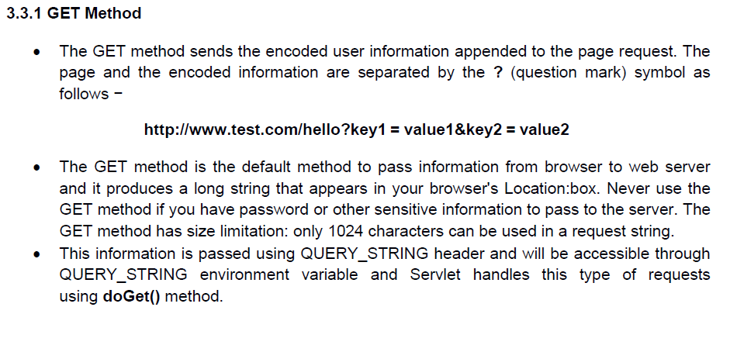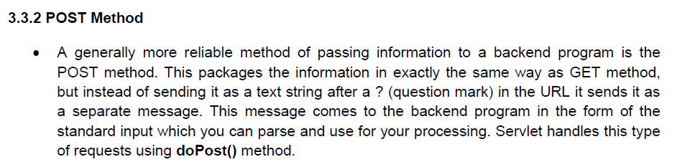

Cookies
  - A webserver can assign a unique session ID as a cookie to each web client and for subsequent requests from the client they can be recognized using the received cookie.
  - This may not be an effective way because many time browser does not support a

  - UNDERSTANDING COOKIES
  - Cookies are text files stored on the client computer and they are kept for various information tracking purpose. Java Servlets transparently supports HTTP cookies.
  - There are three steps involved in identifying returning users – Server script sends a set of cookies to the browser. For example name, age, or identification number etc.
  - Browser stores this information on local machine for future use.
  - When next time browser sends any request to web server then it sends those cookies information to the server and server uses that information to identify the user.
Setting Cookies with Servlet
  - Setting cookies with servlet involves three steps –
  - Creating a Cookie object − You call the Cookie constructor with a cookie name and a cookie value, both of which are strings.
- Cookie cookie = new Cookie("key","value");
  - Keep in mind, neither the name nor the value should contain white space or any of the following characters –
  - [ ] ( ) = , " / ? @ : ; [19]
  - Setting the maximum age − You use setMaxAge to specify how long (in seconds) the cookie should be valid. Following would set up a cookie for 24 hours.
cookie.setMaxAge(60 * 60 * 24);
  - Sending the Cookie into the HTTP response headers − You use response.addCookie to add cookies in the HTTP response header as follows −
response.addCookie(cookie);
